**SECTION A**

1. **OWNER INFORMATION**

The owner information section contains the data that is collected at the time of order. This is editable and must be updated, if found to be incorrect or have fields missing/ incomplete by the inspector during the inspection.

The contact email and telephone number are the most important and must be verified at the time of the inspection. Without a proper email, the policyholder will not receive an automated copy of the inspection report or be able to login to their account to download the same.

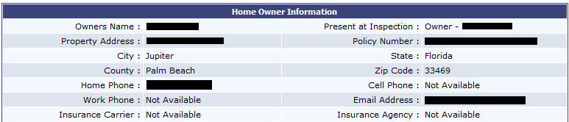

Section A – Figure 1